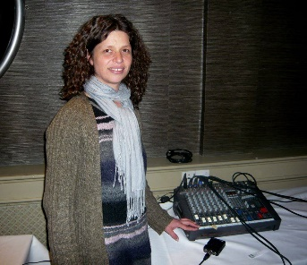
Sofia Arteaga Musician , Sound artist ,Mother
Sofia Arteaga is a French Uruguayan, mother of two teens , residing in Ireland for 14 years, and student in Music production. Sofia grew up in Mexico, Uruguay, Brazil and France, but the longest period of time in one place is in South County Dublin. Completing her honours degree course this year .
Sofia is a world musician experimenting and painting with sound , She draws her audience into the experience as they vocalize and play instruments , with out prior knowledge to create a wave of fascinating sound , evolving all the time . She has presented her work at the Brayarts before and was much loved .
She will present some of her projects for college in the past few years, including sound for animation and video games, contemporaneous composition, and self portraits in sound.
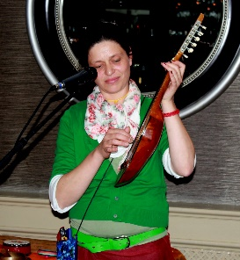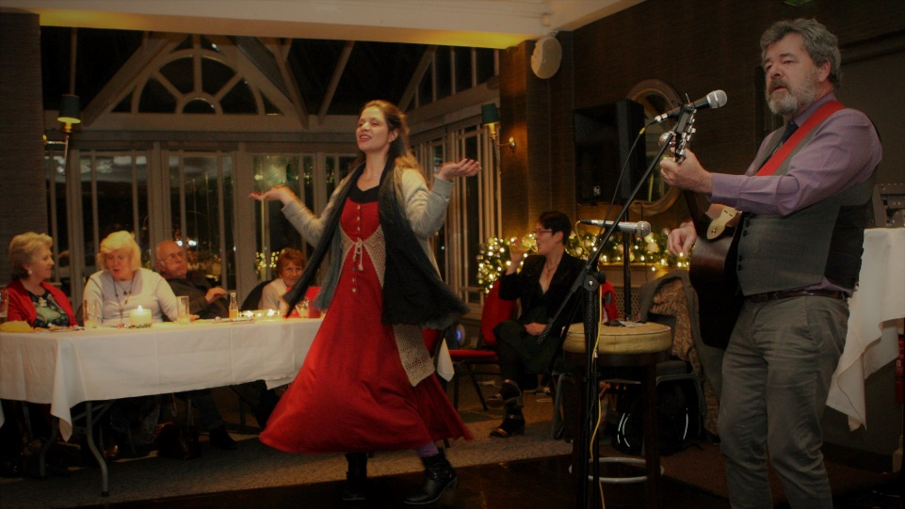

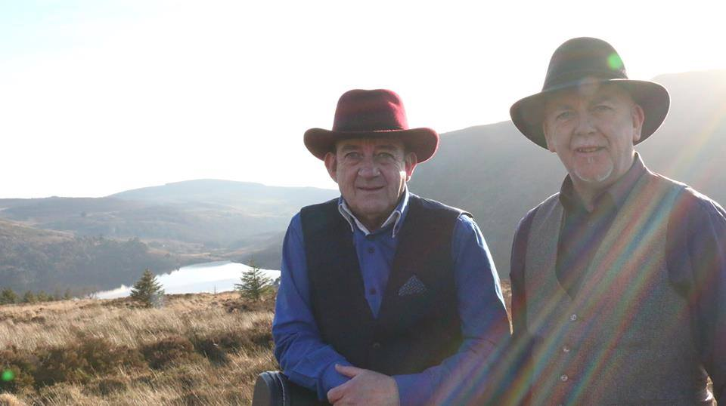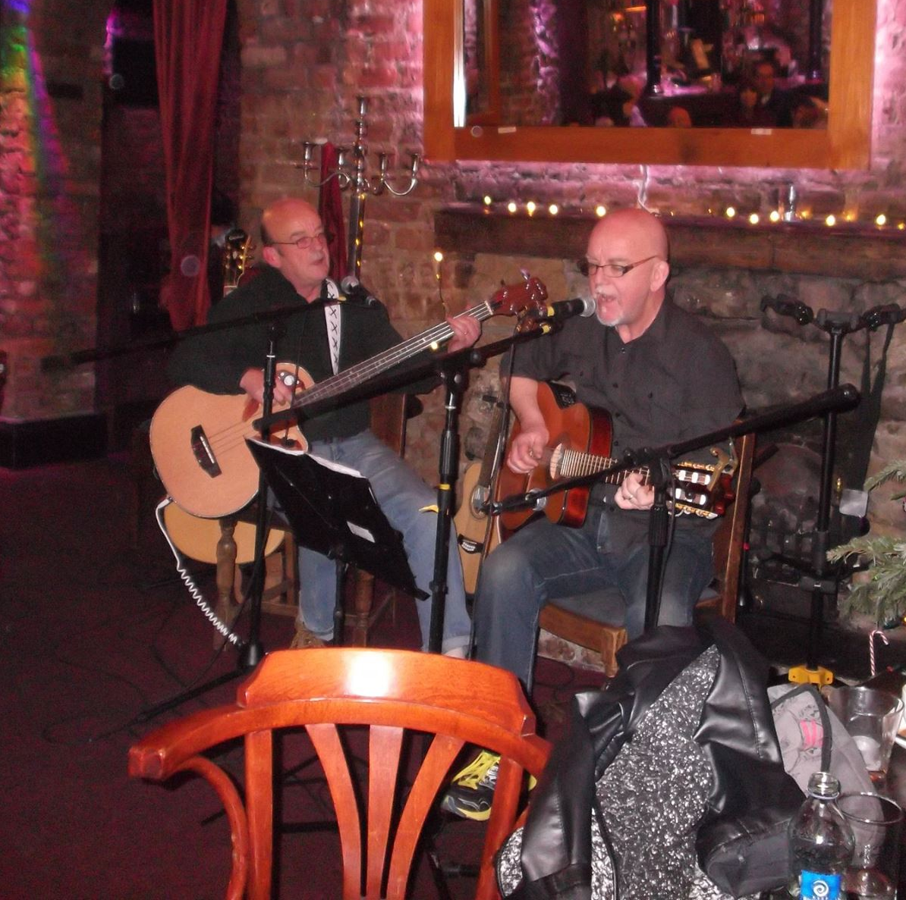
CHUALAINN
John and Enda Kelly have just released their debut single Blue Eyes Crying in the Rain , it will go out on radio and iTunes. There will also be a video on Keep it Country, Sky tv. They have performed the song in RTE studios a family show that will be screened on Saturday evenings in May. The single will also be available on their website www.chualainn.com. The lads have launched the single in the Hotspot Music Club in Greystones on the 16th of March. Two local lads doing what they love.
Enda is also a singer song writer and poet , performing his work at Carmen Cullen’s Arts evenings at the Gato Negro Café in Bray .
John and Enda have presented their work at the Brayarts with their magnificent harmonies with also their passion for the Everly Brothers .

BRAY ARTS SHOW
Tuesday 3rd April @ 8pm
Venue Jim Doyle’s Back Bar Bray Seafront
Adm: 5 euros
Conc: 4 euros
Info contact Julie-Rose McCormick mob.087-2486751

Sofia Arteaga is a French Uruguayan , World Musician and Sound painter .
She will take you on a journey with sound , a mystery tour , but you can never predict where it will go always a surprise , jump on the wagon and follow , for she is a pied piper indeed .
She will present some of her projects for college in the past few years, including sound for animation and video games, contemporaneous composition, and self portraits in sound.

CHUALAINN
John and Enda Kelly have just released their debut single Blue Eyes Crying in the Rain , it will go out on radio and iTunes. There will also be a video on Keep it Country, Sky tv. They have performed the song in RTE studios a family show that will be screened on Saturday evenings in May. The single will also be available on their website www.chualainn.com.

